

Practices for Secure Software Report

Table of Contents
Document Revision History 3
Client 3
Instructions 3
Developer 4
1. Algorithm Cipher 4
2. Certificate Generation 4
3. Deploy Cipher 4
4. Secure Communications 4
5. Secondary Testing 4
6. Functional Testing 4
7. Summary 4
8. Industry Standard Best Practices 4

Document Revision History

Version | Date | Author | Comments
1.0 | October 15, 2026 | Daniel Sullivan | Initial report: SHA-256 checksum, HTTPS, and security testing

Client



Instructions

Submit this completed practices for secure software report. Replace the bracketed text with the relevant information. You must document your process for writing secure communications and refactoring code that complies with software security testing protocols.

- Respond to the steps outlined below and include your findings.
- Respond using your own words. You may also choose to include images or supporting materials. If you include them, make certain to insert them in all the relevant locations in the document.
- Refer to the Project Two Guidelines and Rubric for more detailed instructions about each section of the template.

Developer
Daniel Sullivan

Algorithm Cipher

Recommendation. Artemis Financial wants a file verification step so that when data is transferred through its web application, the recipient can confirm the data arrived unaltered. I recommend SHA-256, a member of the SHA-2 family, as the algorithm cipher for that checksum. It should be delivered over a TLS connection that is secured with a 2048-bit RSA certificate. SHA-256 is one of the names in the Java Security Standard Algorithm Names (Oracle, n.d.), so it is built into every Java runtime through the MessageDigest class. That let me add the feature without a third-party library, which means no new dependency and no new place for a vulnerability to come from.

Overview. SHA-256 is a cryptographic hash function. It accepts input of any length and produces a fixed 256-bit digest, normally displayed as 64 hexadecimal characters. The function is deterministic, so the same input always gives the same digest, and it is one way, so the digest cannot be reversed to recover the input. It also has a strong avalanche effect: changing a single character of the input changes roughly half of the output bits. Those properties are what make it useful as a checksum. If the checksum the client calculates matches the one the server published, the data is the same.
Hash functions and bit levels. The bit level of a hash sets its strength. Because of the birthday bound, a hash with an n-bit output gives about n/2 bits of collision resistance, so SHA-256 gives about 128 bits against collisions and 256 bits against preimage attacks (National Institute of Standards and Technology [NIST], 2015). The older options do not hold up. MD5 has a 128-bit output and collisions can be produced in seconds on a laptop. SHA-1 has a 160-bit output, and a real collision was published in 2017 (Stevens et al., 2017). The SHA-2 family offers 224, 256, 384, and 512-bit outputs, and SHA-3 offers the same sizes with a different internal design. I chose SHA-256 over SHA-512 because 128 bits of collision resistance is already beyond any practical attack and the shorter checksum is easier for a person to compare. For the certificate, a 2048-bit RSA key provides about 112 bits of security, which NIST accepts through 2030 (Barker, 2020), and the certificate itself is signed with SHA256withRSA.
Random numbers and symmetric versus non-symmetric keys. A hash uses no key and no randomness, which is exactly why a checksum can be reproduced by anyone. The secure channel around it depends on both. Symmetric encryption such as AES uses one shared secret key to encrypt and decrypt. It is fast and suited to large amounts of data, but both sides need the key ahead of time. Non-symmetric (asymmetric) encryption such as RSA uses a public and private key pair. It is much slower, but it solves the key distribution problem and makes digital signatures possible. TLS uses the two together: the asymmetric key pair in the certificate authenticates the server during the handshake, the two sides agree on a session key, and a symmetric cipher encrypts the traffic from then on. Random numbers hold all of this up. Key pairs, session keys, nonces, and initialization vectors must come from a cryptographically secure generator such as java.security.SecureRandom, not java.util.Random. A strong algorithm with predictable random numbers is a weak system. The Keytool uses a secure generator when it creates the RSA key pair.
One limit is worth stating. A checksum alone proves integrity, not confidentiality or origin. An attacker who can alter a file in transit could also alter a checksum sent beside it. That is why I deployed the checksum over HTTPS, which authenticates the server and protects the checksum on its way to the client. If Artemis Financial later needs to prove who produced a file, the next step would be a keyed hash (HMAC-SHA-256) or a digital signature.
History and current state. Encryption began with simple substitution ciphers and moved to mechanical ciphers such as Enigma during World War II. The modern era started in the 1970s. Diffie and Hellman introduced public key exchange in 1976, RSA followed in 1977, and DES became the United States federal standard in 1977 with a 56-bit key. By 1998 a DES key could be found by brute force in days, so Triple DES served as a stopgap until NIST standardized AES in 2001 after an open competition. Hash functions followed the same pattern. MD5 (1992) and SHA-1 (1995) were used everywhere until collisions were found, in 2004 and 2017. SHA-2, published in 2001, remains the standard today, and SHA-3 was added in 2015 as a structurally different backup. Today the accepted set is AES with 128 or 256-bit keys, SHA-2 or SHA-3, RSA at 2048 bits or more or elliptic curve keys, and TLS 1.2 or 1.3. SSL and TLS 1.0 and 1.1 are deprecated. Looking ahead, large quantum computers would break RSA and elliptic curve cryptography, and NIST published its first post-quantum standards in 2024 for that reason. Hash functions are much less exposed, since the best-known quantum attack only halves the effective preimage strength. SHA-256 would still offer about 128 bits, so it is a sound long-term choice for Artemis Financial.

Certificate Generation
I generated a self-signed certificate with the Java Keytool. The first command creates a 2048-bit RSA key pair and a certificate signed with SHA256withRSA, and stores them in a PKCS12 keystore, which is the industry standard format that replaced the Java-only JKS format. The subject alternative name is set to localhost, so the certificate matches the address the server runs on. The second command exports the public certificate to a CER file.
keytool -genkeypair -alias tomcat -keyalg RSA -keysize 2048 -sigalg SHA256withRSA -storetype PKCS12 -keystore keystore.p12 -validity 365 -dname "CN=Daniel Sullivan, OU=CS 305, O=Southern New Hampshire University, L=Manchester, ST=New Hampshire, C=US" -ext "SAN=dns:localhost,ip:127.0.0.1"
keytool -exportcert -alias tomcat -keystore keystore.p12 -file server.cer
A self-signed certificate is appropriate for development and testing because it provides the same encryption as any other certificate. It does not provide third-party proof of identity, so for production Artemis Financial should replace it with a certificate issued by a trusted certificate authority.

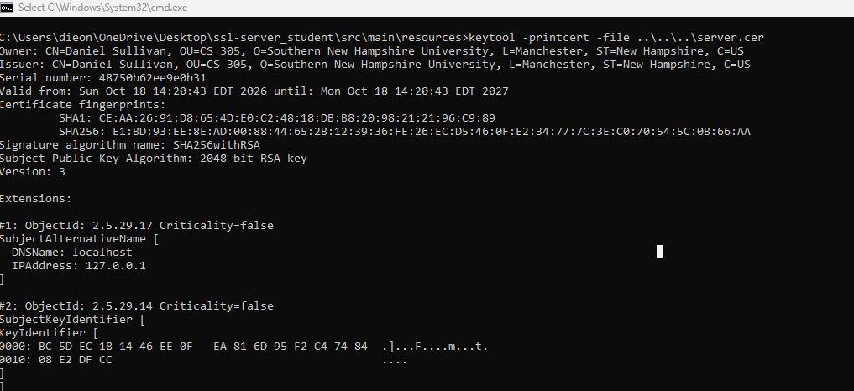

Deploy Cipher
I refactored the code base to deploy SHA-256 and removed the FIXME left in SslServerApplication.java. The work is split into two new classes, so each has one job. ChecksumGenerator holds the hashing logic. It requests SHA-256 from MessageDigest, converts the text to bytes with an explicit UTF-8 character set so the result is the same on every platform, and converts the 32 hash bytes to a 64-character hexadecimal string. ServerController is a REST controller that maps a GET request for /hash, hashes a unique data string that contains my name, and returns the data, the algorithm name, and the checksum.
The data string is:
Daniel Sullivan - CS 305 Project Two - Artemis Financial checksum verification
The checksum the application returns for it is:
5e2b86a8901fd979ba62c9669b9bc8c17df4682ac45c32f1eea2e7aeb95deb3b
The checksum can be verified independently: hashing the same string with any standard SHA-256 tool, such as PowerShell's Get-FileHash, produces the identical value. I also added unit tests (ChecksumGeneratorTests) that check the implementation against the published SHA-256 test vectors for "abc" and for the empty string, confirm the output is always 64 characters, and confirm that a one-character change in the data produces a different checksum.

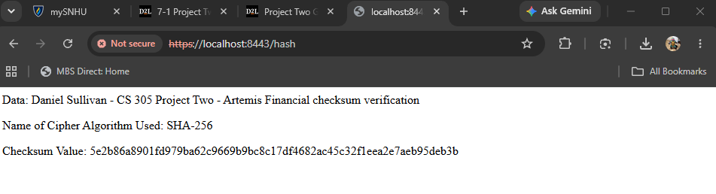

Secure Communications
To convert the application from HTTP to HTTPS, I replaced the placeholder values in application.properties with the entries below. The server now listens only on port 8443 with TLS and loads the certificate from the keystore on the classpath. I also restricted the server to TLS 1.2 and 1.3 so that a client cannot negotiate a deprecated protocol version.
server.port=8443
server.ssl.enabled=true
server.ssl.key-alias=tomcat
server.ssl.key-store-password=(keystore password)
server.ssl.key-store=classpath:keystore.p12
server.ssl.key-store-type=PKCS12
server.ssl.enabled-protocols=TLSv1.2,TLSv1.3
After compiling and running the application, I opened https://localhost:8443/hash in a browser. The page loads over HTTPS and the browser's certificate viewer shows the certificate I generated. Because the certificate is self-signed, a browser warns that it was not issued by a trusted authority until the certificate is trusted on the local machine. The traffic is encrypted in either case.

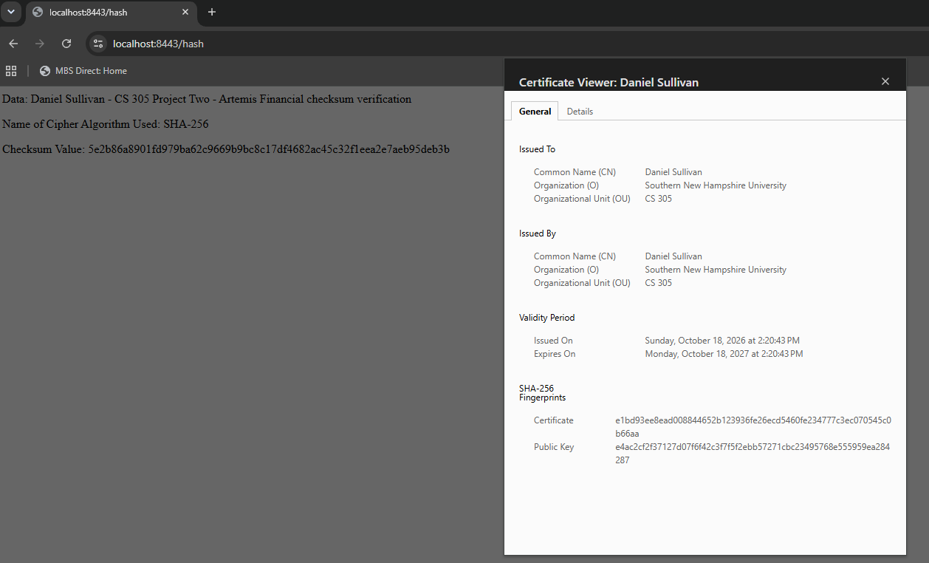

Secondary Testing
After refactoring, I ran the OWASP dependency-check Maven plugin against the project as a secondary static test. The plugin version in the original code base (5.3.0) depends on NVD data feeds that have been retired, so I updated it to version 12.1.0, which uses the current NVD API. This changed only the testing tool, not the application's dependencies. The purpose was to confirm that my changes did not introduce any new vulnerable components. They could not have, by design: the new code uses only java.security classes from the JDK and Spring classes that were already in the project, so the dependency list in pom.xml is unchanged from the original code base. The report scanned 49 dependencies and listed 16 vulnerable dependencies with 295 known vulnerabilities in total. All of them are libraries that came with the original Spring Boot 2.2.4 code base, such as Tomcat 9.0.30, Spring Framework 5.2.3, jackson-databind 2.10.2, and snakeyaml 1.25, and none were introduced by my refactoring. The most serious findings include CVE-2022-22965 (Spring4Shell) in Spring Framework 5.2.3 and CVE-2022-1471 in snakeyaml 1.25, both of which allow remote code execution. Both are fixed in later versions, which is why upgrading Spring Boot is my top recommendation.

The findings that remain belong to the existing framework version and are outside the scope of this refactoring. My recommendation to Artemis Financial is to upgrade the Spring Boot parent to a currently supported release in a separate change, then run the dependency check again, since most of the reported vulnerabilities have fixes in later versions.

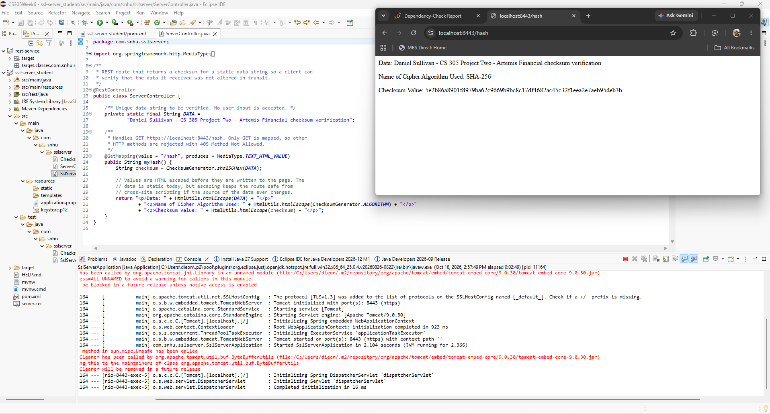
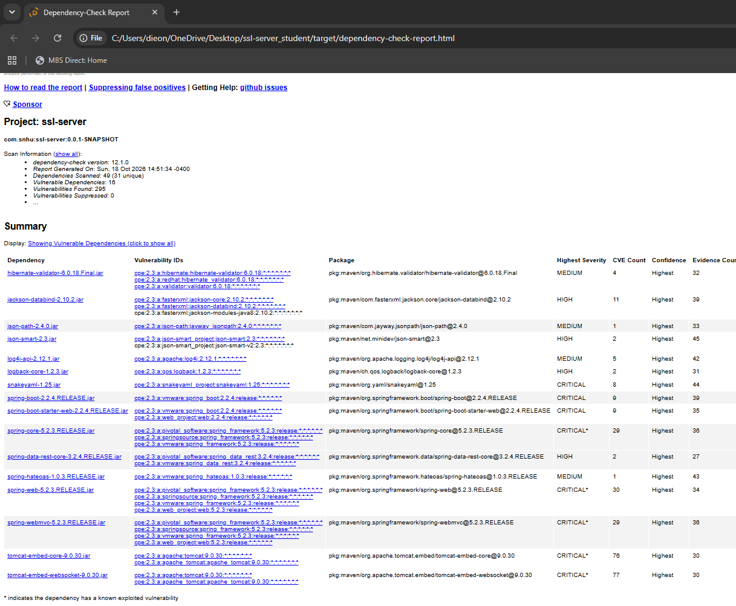

Functional Testing
I manually reviewed every file I added or changed, looking for syntactical, logical, and security problems.
Syntactical. The project compiles at the Java 8 language level set in pom.xml with no errors. Imports are limited to what each class uses, and the code avoids newer language features that Java 8 would reject.
Logical. All six unit tests pass, including checks against the published SHA-256 test vectors, so the hashing and the hexadecimal conversion are correct. I checked two common mistakes in particular. The byte-to-hex conversion masks each byte with 0xFF and always writes two characters, so negative byte values and leading zeros are handled and the checksum is always 64 characters. The text is converted to bytes with UTF-8 stated explicitly, so the result does not depend on the default character set of the machine. A null input is rejected with a clear exception.
Security. The /hash route accepts no parameters, headers, or request body, so there is no user input that could be used for injection. The values written to the page are HTML escaped anyway, which protects against cross-site scripting if the data source ever changes. Only GET is mapped, so other HTTP methods are refused. If SHA-256 were ever unavailable, the code throws an exception and stops. It does not fall back to a weaker algorithm, and it does not return a stack trace or other internal detail to the client. MD5 and SHA-1 are not used anywhere. The server accepts only TLS 1.2 and 1.3.
Remaining items. The review found one issue I chose to document instead of change. The keystore password is stored in plain text in application.properties and the keystore is packaged with the project. That is acceptable for a development build with a self-signed certificate, but in production the password should come from an environment variable or a secrets manager and the keystore should be kept outside the code repository. The outdated Spring Boot version noted in the secondary testing section also remains.

Summary

I refactored Artemis Financial's application to add a checksum verification step and to move all communication from HTTP to HTTPS. Using the vulnerability assessment process flow diagram as a guide, the refactoring addressed the following areas of security.
Cryptography. A SHA-256 checksum now verifies data integrity, and a 2048-bit RSA certificate signed with SHA-256 secures the connection. No deprecated algorithm is used.
Client/Server. The server accepts only HTTPS on port 8443 and only TLS 1.2 or 1.3, so data and checksums are encrypted in transit and the client can identify the server by its certificate.
APIs. The new REST endpoint exposes the smallest possible surface: one GET route with no inputs and a fixed response format.
Code Error. The one checked exception in the hashing code is handled deliberately. The code fails closed and reveals nothing internal to the client.
Code Quality and Encapsulation. Hashing logic is separated from the web layer, the utility class is final with a private constructor, constants are private where they can be, and unit tests cover the checksum logic. Output is encoded before it is written to the page, which covers the input validation area even though the route currently takes no input.
My process for adding layers of security followed the order of this report. I first chose the algorithm based on the client's need for file verification. I then generated the certificate, implemented and verified the checksum, and enabled HTTPS. With the application running, I ran the dependency-check tool to confirm the refactoring added no vulnerable components, and finished with a manual review of the code. Each layer protects against a different failure: the checksum detects altered data, TLS prevents the data and the checksum from being read or changed in transit, and the testing steps catch mistakes in the code and its libraries. If any step had shown a new vulnerability, the plan was to fix it and repeat the tests until none remained.

Industry Standard Best Practices

I applied several industry standard best practices for secure coding in this refactoring. I used a vetted, standard cryptographic implementation (the JDK's MessageDigest) instead of writing my own, and chose an algorithm approved by NIST. I encrypted data in transit with current TLS versions. I kept the attack surface small by exposing a single read-only route with no inputs. I encoded output, handled errors so that they fail securely, and separated responsibilities so the security-relevant code is small enough to review and test. These follow the guidance in the OWASP Secure Coding Practices (OWASP Foundation, 2010).
To maintain the application's existing security, I kept the change narrow. I did not add, remove, or downgrade any dependency, and I did not loosen any existing configuration. The server still runs on the port the client already used. I then ran the dependency check after refactoring and confirmed that every flagged library was already part of the original code base, and reviewed my own code by hand so that the new functionality did not open a new weakness. Where I found something I could not fix inside the scope of this task, such as the plain-text keystore password and the aging framework version, I documented it so it can be scheduled instead of forgotten.
These practices matter to Artemis Financial well beyond this one feature. The company holds savings, retirement, investment, and insurance information for its customers, and its business depends on those customers trusting it with that data. A breach would bring direct costs for response and recovery, possible regulatory penalties in the countries where it operates, and lasting damage to its reputation. Building security in during development is far cheaper than repairing it after an incident, and using recognized standards gives the company something it can show to auditors, partners, and clients as evidence that it takes its mission seriously. It also fits Global Rain's principle that security is everyone's responsibility.

References
Barker, E. (2020). Recommendation for key management: Part 1 - General (NIST Special Publication 800-57 Part 1, Rev. 5). National Institute of Standards and Technology. https://doi.org/10.6028/NIST.SP.800-57pt1r5
National Institute of Standards and Technology. (2015). Secure hash standard (SHS) (FIPS PUB 180-4). U.S. Department of Commerce. https://doi.org/10.6028/NIST.FIPS.180-4
Oracle. (n.d.). Java security standard algorithm names. https://docs.oracle.com/en/java/javase/17/docs/specs/security/standard-names.html
OWASP Foundation. (2010). OWASP secure coding practices quick reference guide (Version 2.0). https://owasp.org/www-project-secure-coding-practices-quick-reference-guide/
Stevens, M., Bursztein, E., Karpman, P., Albertini, A., & Markov, Y. (2017). The first collision for full SHA-1 (Paper 2017/190). Cryptology ePrint Archive. https://eprint.iacr.org/2017/190

